Lab 7: UI Design for Flight Check-in Machine

Most of the airlines allow their travelers do self-check in at automatic machines. The user may identify himself in several ways like placing a machine readable ID card or passport, inserting credit card or the airline (Frequent flyer card) or simply by providing some textual information (last name + booking reference, e-ticket number) etc.
For this particular lab assignment, you have to design the screens that allow self check-in by getting information from the traveler (You may need to display an on-screen keyboard for this purpose). The user should also be provided with an option to select his seat(s). At the end of the session, the machine will print the Boarding Pass(es) for the traveler(s). In case the person is traveling with baggage, direct him to an appropriate counter for depositing the baggage.

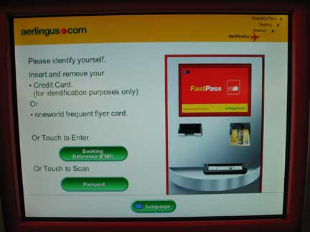 | 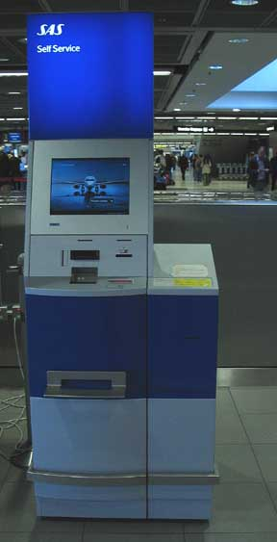

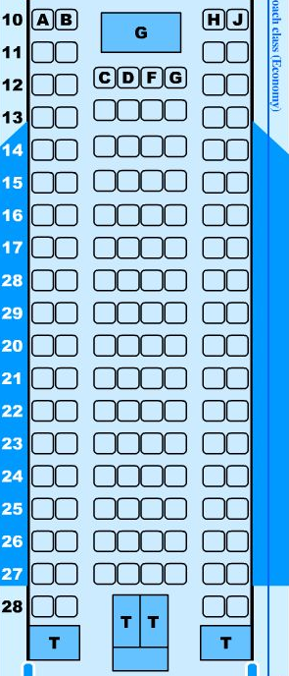
Figure: A part of airbus seat layout for economy class

